To create Java project, follow the below steps in Eclipse IDE

Start Eclipse IDE in your machine.

Once you start IDE it will open below Dialog box and here you have to define your project workspace ***either in default path or give your own folder location*** for project then click on Launch.

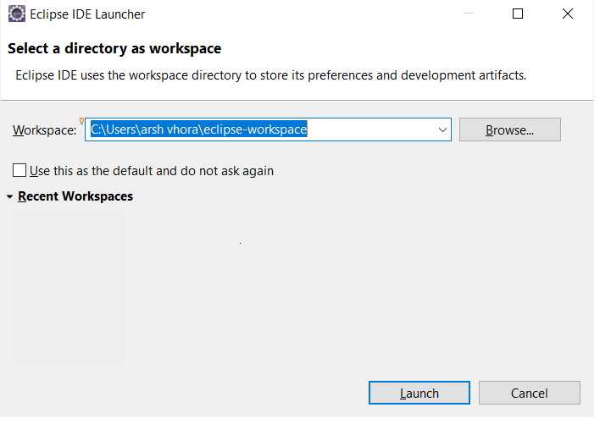

It will open below screen.

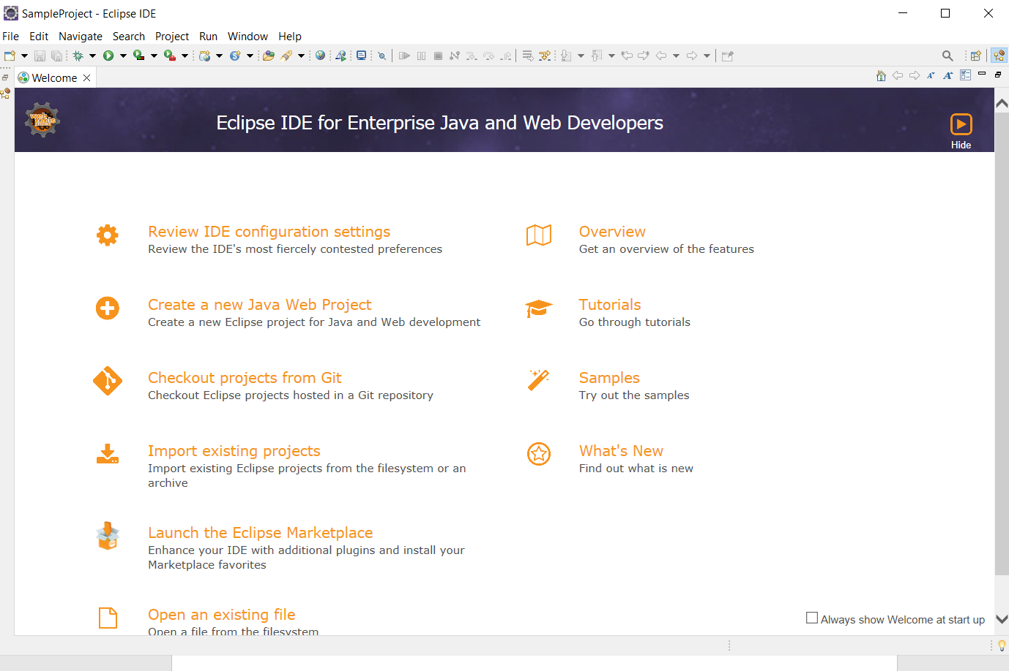

To create Java Project, follow the below steps.

1) Click FILE Menu -> NEW -> Java Project ( **If Java project it not available in popup, then choose other menu, it will open another dialog box and select Java option to create java project** )

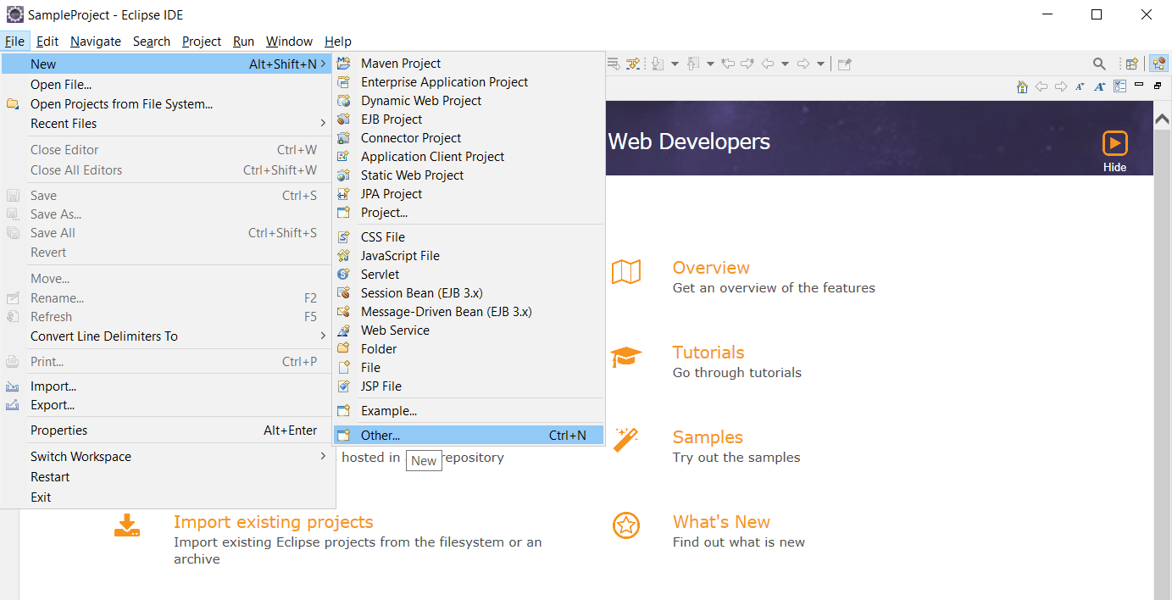

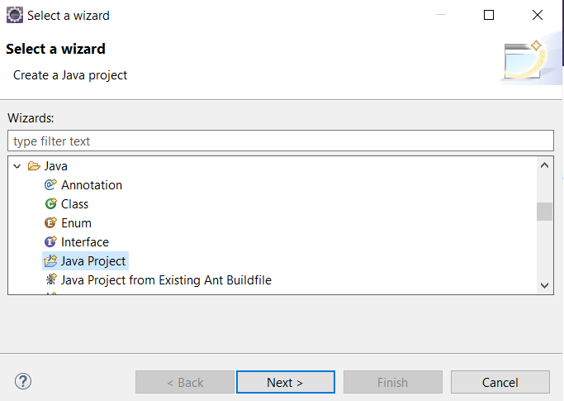

Then, click next

Now here you can give name of the project. **No need to change or set any properties** in this dialog box.

Once you specify the name of the project Next button is enable to do further steps.

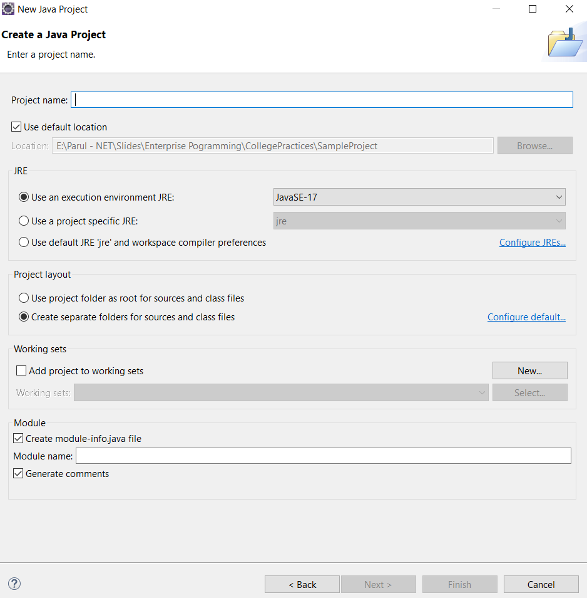

It will open below dialog box.

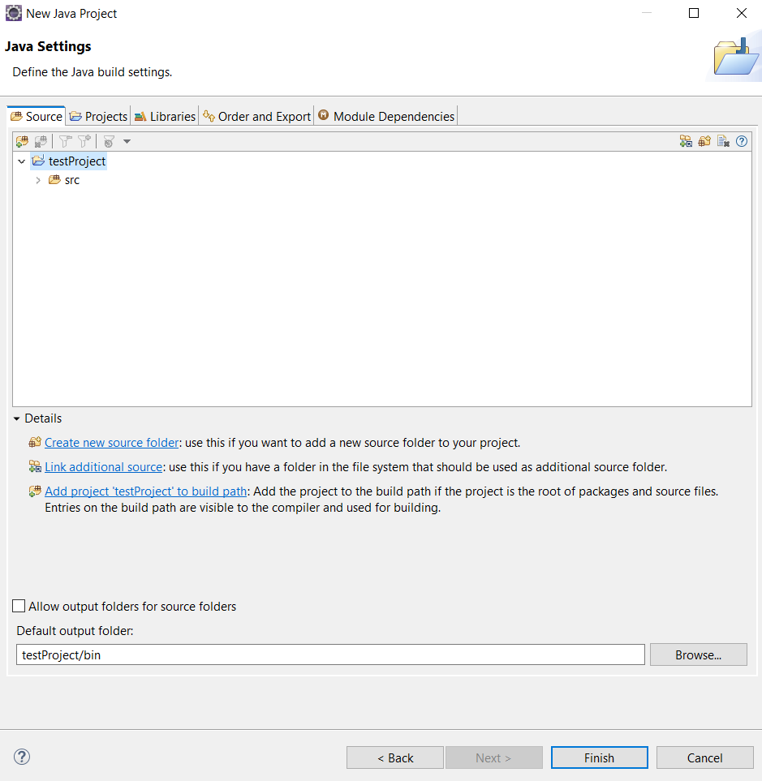

Now Click on Finish, it will open dialog box just click on **NO** to create Java project.

To view Project explorer follow the image steps ( **Window -> Show View -> Project Explorer** )

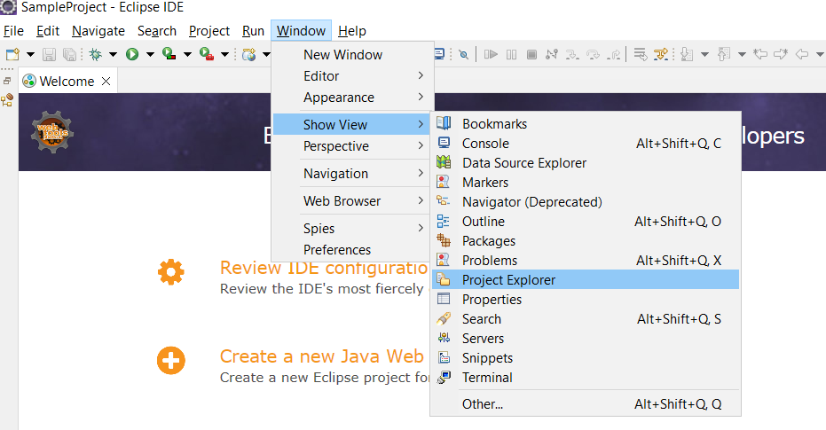

Will display below window in Eclipse IDE

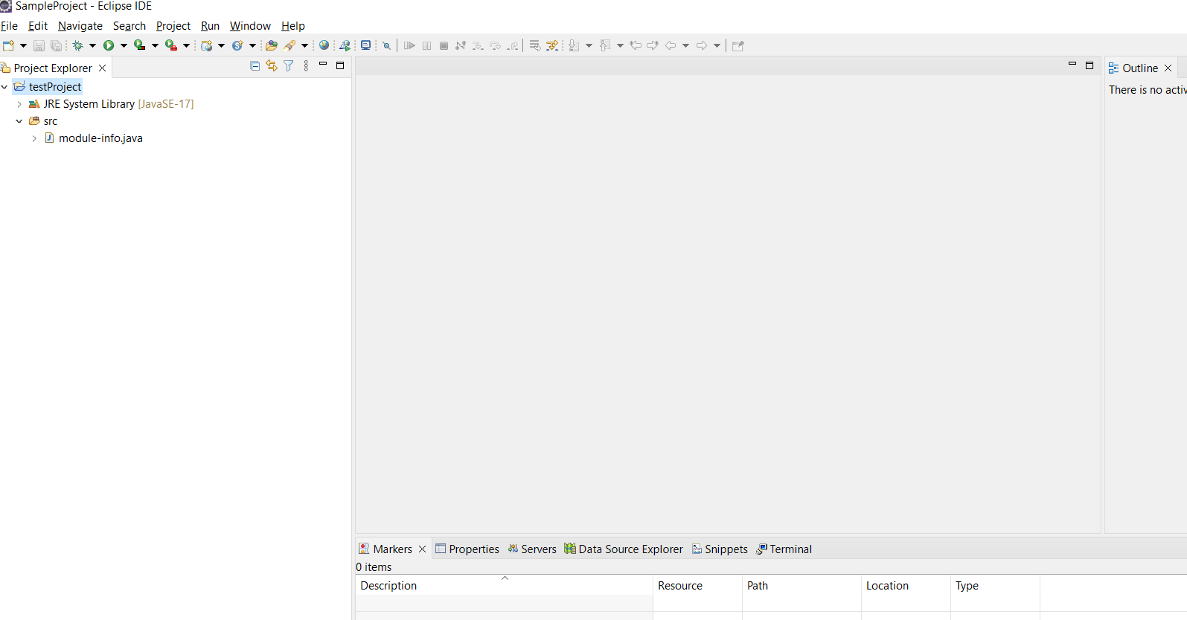

For JDBC java project you need to download MySql connector () from MySql Official site. Once you download you need to attached JAR file to project.

Follow the below steps.

1) Righclick the project, **select the build path -> Configure Build Path**

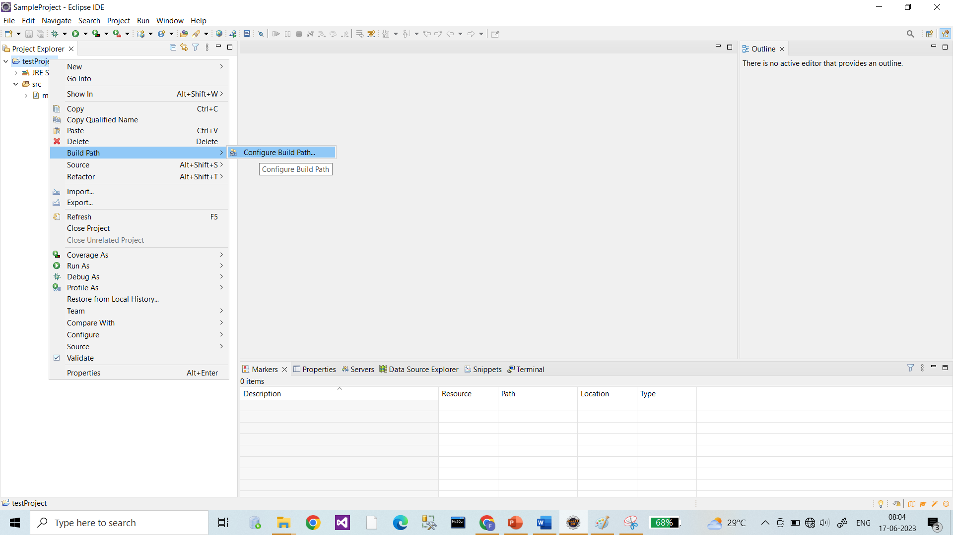

Now it will open below dialog box

Here Click on **libraries TAB** and click on Modulepath to make it enabled **ADD EXTERNAL JARs…button**

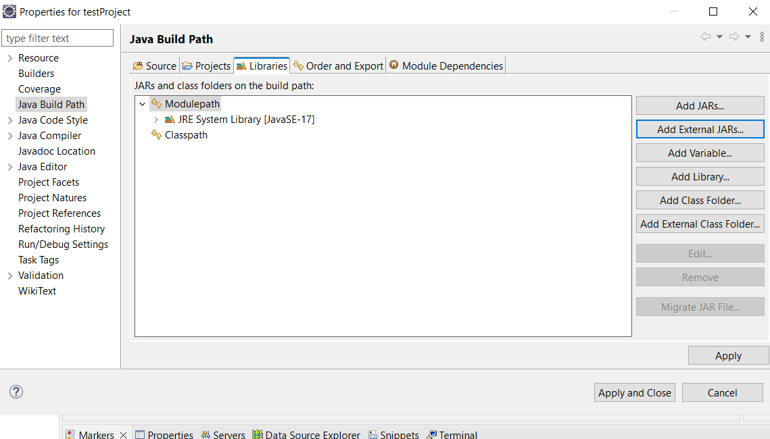

Once you click on **ADD EXTERNAL JARs…button, it will open another dialog which allows you to add ( mysql-connector-java-8.0.11 ) to the project.**

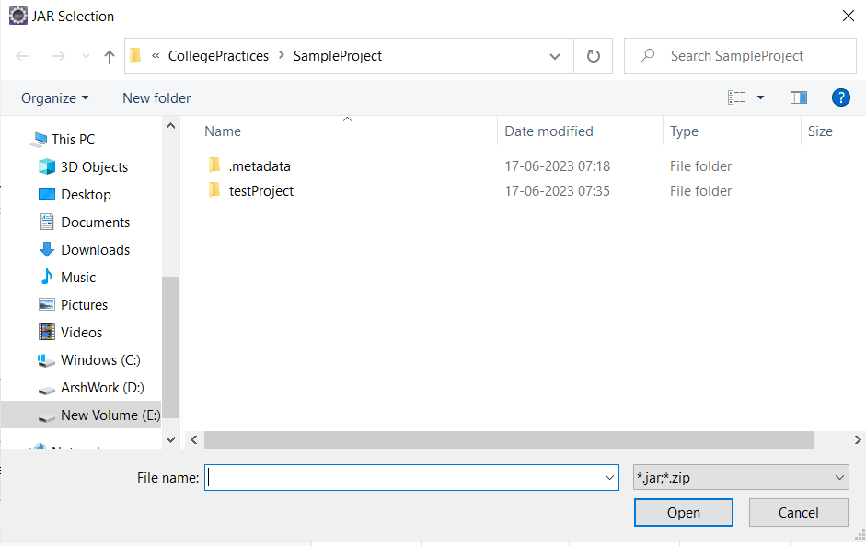

**Here you have to choose path where you downloaded ( mysql-connector-java-8.0.11 ).**

**Then click APPLY button and APPLY and CLOSE button.**

**Once done Please ensure it is available in REFERENCED LIBRARIES or not**

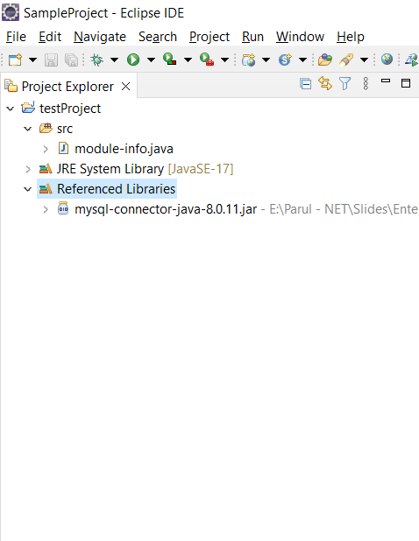

Next, you need to add below lines of code in **module-info.java** file which is available under SRC folder of the project.

**module** testProject {

**requires** java.sql;

}